Three-dimensional structure of proteins
- The covalent backbone of a typical protein contains hundreds of individual bonds. Because free rotation is possible around many of these bonds, the protein can assume an unlimited number of conformations. However, each protein has a specific chemical or structural function, strongly suggesting that each has a unique three-dimensional structure.
- The spatial arrangement of atoms in a protein is called its conformation. The possible conformations of a protein include any structural state that can be achieved without breaking covalent bonds. A change in conformation could occur, for example, by rotation about single bonds.
- Proteins in any of their functional, folded conformations are called native proteins.
Protein Secondary Structure
The term secondary structure refers to the local conformation of some part of a polypeptide.
The secondary structure most usefully focuses on common regular folding patterns of the polypeptide backbone.
A few types of secondary structure are particularly stable and occur widely in proteins. The most prominent are the α helix and β conformations.
α helix
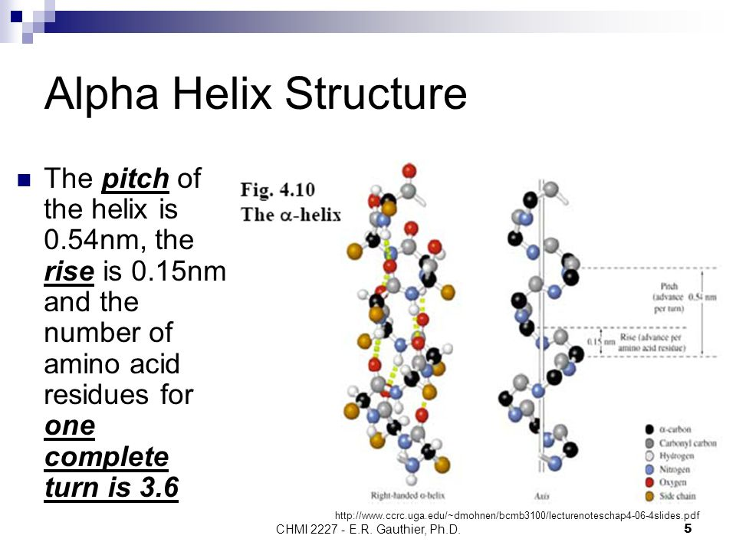
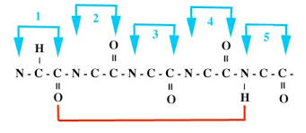
The α-helix is a right-handed coiled strand. The side-chain substituents of the amino acid groups in an α-helix extend to the outside.
The structure is stabilized by a hydrogen bond between the hydrogen atom attached to the electronegative nitrogen atom of a peptide linkage and the electronegative carbonyl oxygen atom of the fourth amino acid on the amino-terminal side of that peptide bond.
Within the α helix, every peptide bond (except those close to each end of the helix) participates
in such hydrogen bonding. Each successive turn of the α helix is held to adjacent turns by three to four hydrogen bonds. All the hydrogen bonds combined give the entire helical structure considerable stability.
Five different kinds of constraints affect the stability of an α helix:
- The electrostatic repulsion (or attraction) between successive amino acid residues with charged R groups: For example, if a polypeptide chain has a long block of Glu residues, this segment of the chain will not form an α helix at pH 7.0. The negatively charged carboxyl groups of adjacent Glu residues repel each other so strongly that they prevent formation of the α helix.
- The bulkiness of adjacent R groups: The bulk and shape of Asn, Ser, Thr, and Cys residues can also destabilize an α helix if they are close together in the chain.
- The interactions between R groups spaced three (or four) residues apart: The twist of an _ helix ensures that critical interactions occur between an amino acid side chain and the side chain three (and sometimes four) residues away on either side of it. Positively charged amino acids are often found three residues away from negatively charged amino acids, permitting the formation of an ion pair. Two aromatic amino acid residues are often similarly spaced, resulting in a hydrophobic interaction.
- The occurrence of Pro and Gly residues: In proline, the nitrogen atom is part of a rigid ring, and rotation about the N-C_{α} bond is not possible. Thus, a Pro residue introduces a destabilizing kink in an α helix. In addition, the nitrogen atom of a Pro residue in peptide linkage has no substituent hydrogen to participate in hydrogen bonds with other residues. For these reasons, proline is only rarely found within an α helix. Glycine occurs infrequently in α helices for a different reason: it has more conformational flexibility than the other amino acid residues. Polymers of glycine tend to take up coiled structures quite different from an α helix.
- The interaction between amino acid residues at the ends of the helical segment and the electric dipole inherent to the α helix: The tendency of a given segment of a polypeptide chain to fold up as an α helix therefore depends on the identity and sequence of amino acid residues within the segment. A small electric dipole exists in each peptide bond. These dipoles are connected through the hydrogen bonds of the helix, resulting in a net dipole extending along the helix that increases with helix length. The four amino acid residues at each end of the helix do not participate fully in the helix hydrogen bonds. The partial positive and negative charges of the helix dipole actually reside on the peptide amino and carbonyl groups near the amino-terminal and carboxyl-terminal ends of the helix, respectively. For this reason, negatively charged amino acids are often found near the amino terminus of the helical segment, where they have a stabilizing interaction with the positive charge of the helix dipole; a positively charged amino acid at the amino terminal end is destabilizing. The opposite is true at the carboxyl-terminal end of the helical segment.

β-sheets
The hydrogen bonding in a ß-sheet is between strands (inter-strand) rather than within strands (intra-strand). The sheet conformation consists of pairs of strands lying side-by-side. The carbonyl oxygens in one strand hydrogen bond with the amino hydrogens of the adjacent strand. The two strands can be either parallel or anti-parallel depending on whether the strand directions (N-terminus to C-terminus) are the same or opposite. The anti-parallel ß-sheet is more stable due to the more well-aligned hydrogen bonds.
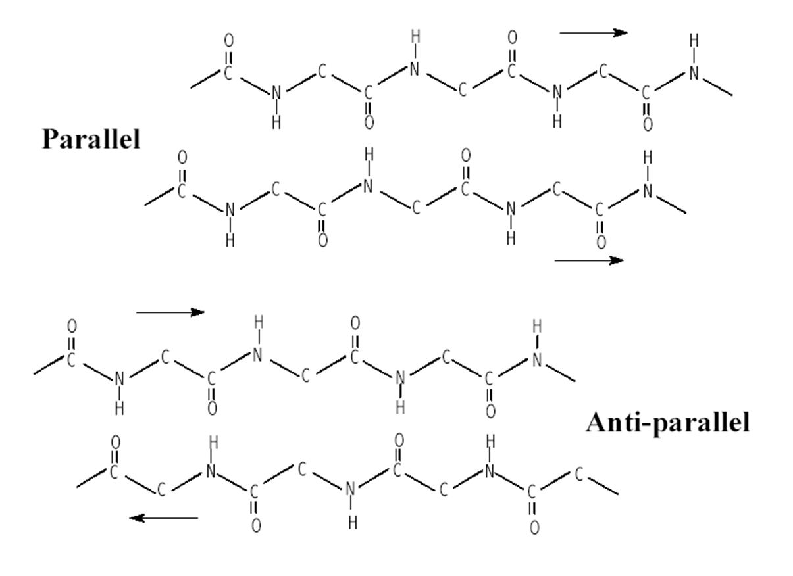
β-turns
- In globular proteins, which have a compact folded structure, nearly one-third of the amino acid residues are in turns or loops where the polypeptide chain reverses direction These are the connecting elements that link successive runs of α helix or β conformation.
- Particularly common are β turns that connect the ends of two adjacent segments of an antiparallel β sheet.
- The structure is a 180˚ turn involving four amino acid residues, with the carbonyl oxygen of the first residue forming a hydrogen bond with the amino-group hydrogen of the fourth. The peptide groups of the central two residues do not participate in any inter-residue hydrogen bonding.
- Of the several types of β turns, two are the most common; type I and type II.
- Gly and Pro residues often occur in β turns, the former because it is small and flexible, the latter because peptide bonds involving the imino nitrogen of proline readily assume the cis configuration, a form that is particularly amenable to a tight turn.
- Beta turns are often found near the surface of a protein, where the peptide groups of the central two amino acid residues in the turn can hydrogen-bond with water. Considerably less common is the γ turn, a three residue turn with a hydrogen bond between the first and third residues.
Figure: Relative probabilities that a given amino acid will occur in the three common types of secondary structure

Tertiary Structure
The overall three-dimensional shape of an entire protein molecule is the tertiary structure. The protein molecule will bend and twist in such a way as to achieve maximum stability or lowest energy state. Although the three-dimensional shape of a protein may seem irregular and random, it is fashioned by many stabilizing forces due to bonding interactions between the side-chain groups of the amino acids. The formation of disulfide bridges by oxidation of the sulfhydryl groups on cysteine is an important aspect of the stabilization of protein tertiary structure, allowing different parts of the protein chain to be held together covalently. Additionally, hydrogen bonds may form between different side-chain groups. As with disulfide bridges, these hydrogen bonds can bring together two parts of a chain that are some distance away in terms of sequence. Salt bridges, ionic interactions between positively and negatively charged sites on amino acid side chains, also help to stabilize the tertiary structure of a protein.

Quaternary Structure
Many proteins are made up of multiple polypeptide chains, often referred to as protein subunits. These subunits may be the same (as in a homodimer) or different (as in a heterodimer). The quaternary structure refers to how these protein subunits interact with each other and arrange themselves to form a larger aggregate protein complex. The final shape of the protein complex is once again stabilized by various interactions, including hydrogen-bonding, disulfide-bridges and salt bridges.

